Chapter 15, Solution 34.

- 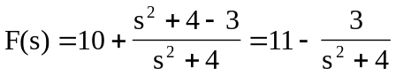

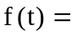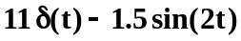

- 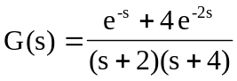

Let 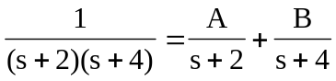

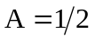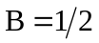

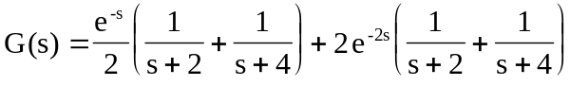

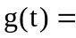

- Let  